**Table of Contents**

TA role log

Weekly theme

Teaching observations and feedback

Micro-video

Micro-teaching / Discussion section feedback

Observing Micro-teaching / Discussion section

Summary of teaching observations

TA role log

*Time spent? Celebrate! What can be improved?*

Pre-quarter set-up / Week 0:

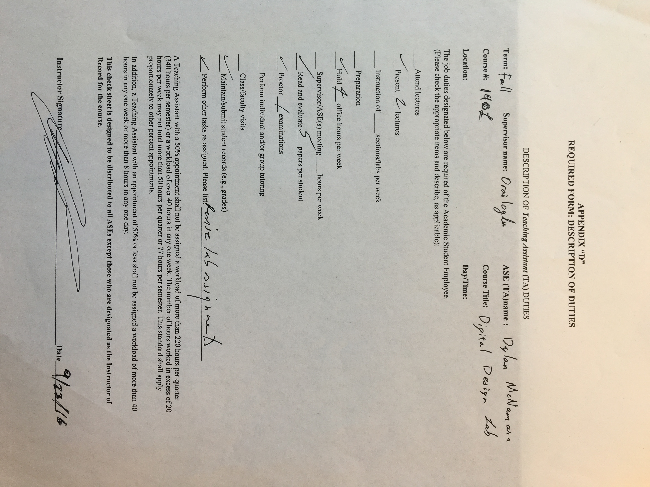

Week 1:

* Time Spent: 12 Hours (I have not had any office hours yet).
* Something Done Well: Working with the tutor to create a tutorial for the students. Also set up Piazza and put material on there for students.
* Something to Improve: I gave students poor information about the class website.

Week 2:

* Time Spent: 17 hours
* Something Done Well: Good turnover of Piazza
* Something to Improve: Work on discussion session. Closing discussions and work on explaining design concepts better

Week 3:

* Time Spent: 23 hours
* Something Done Well: Worked hard to make sure the lab was prepared for the students.
* Something to Improve: Asking for help

Week 4:

Week 5:

Week 6:

Week 7:

Week 8:

Week 9:

Week 10:

Weekly theme

*What you learned? One thing you can use? How you feel?*

Week 0 **Nuts & Bolts**:

* I learned: Cognizance and various techniques for keeping people engaged and involved
* Something I can use: Techniques for student involvement (e.g. Pass the Pen)
* How I feel: I feel better knowing that I have a network of students, TA’s and professors that can help me have trouble and also relieved to know that this class will do more for us than just teach us how to be good TAs

Week 1 **Communication**:

* I learned: To give the big picture when explaining concepts
* Something I can use: Pay attention more to my posture and my eye contact while presenting
* How I feel: Annoyed and discouraged that I didn’t do as well with the connect the dot exercise

Week 2 **How People Learn**:

* I learned: To stick to small examples (think in big pictures, demonstrate in small examples)
* Something I can use: Keep class engaged with learning. Try to view student’s objectives and expectations for the class
* How I feel: Exhausted, overworked, overwhelmed.

Week 3 **Educational Technology**:

* I learned: Connect information throughout a lecture/discussion/presentation or explanation
* Something I can use: Gradescope and resources for gradescope
* How I feel: Disrespected, worn-out, abused, tires, depressed, hopeful

Week 4 **Grad Student Panel**:

Week 5 **Assessment**:

Week 6 **Inclusiveness**:

Week 8 **Communication**:

Week 10 **Next steps**:

Teaching observations and feedback

Micro-video

**Video Link:** [**https://www.youtube.com/watch?v=cblv5VoMjnY**](https://www.youtube.com/watch?v=cblv5VoMjnY)

**PDF for video in repo as: “Video 1 – TeachingObservationForm.pdf”**

Micro-teaching / Discussion section feedback

1. Week 2: observed by Vigneh

.

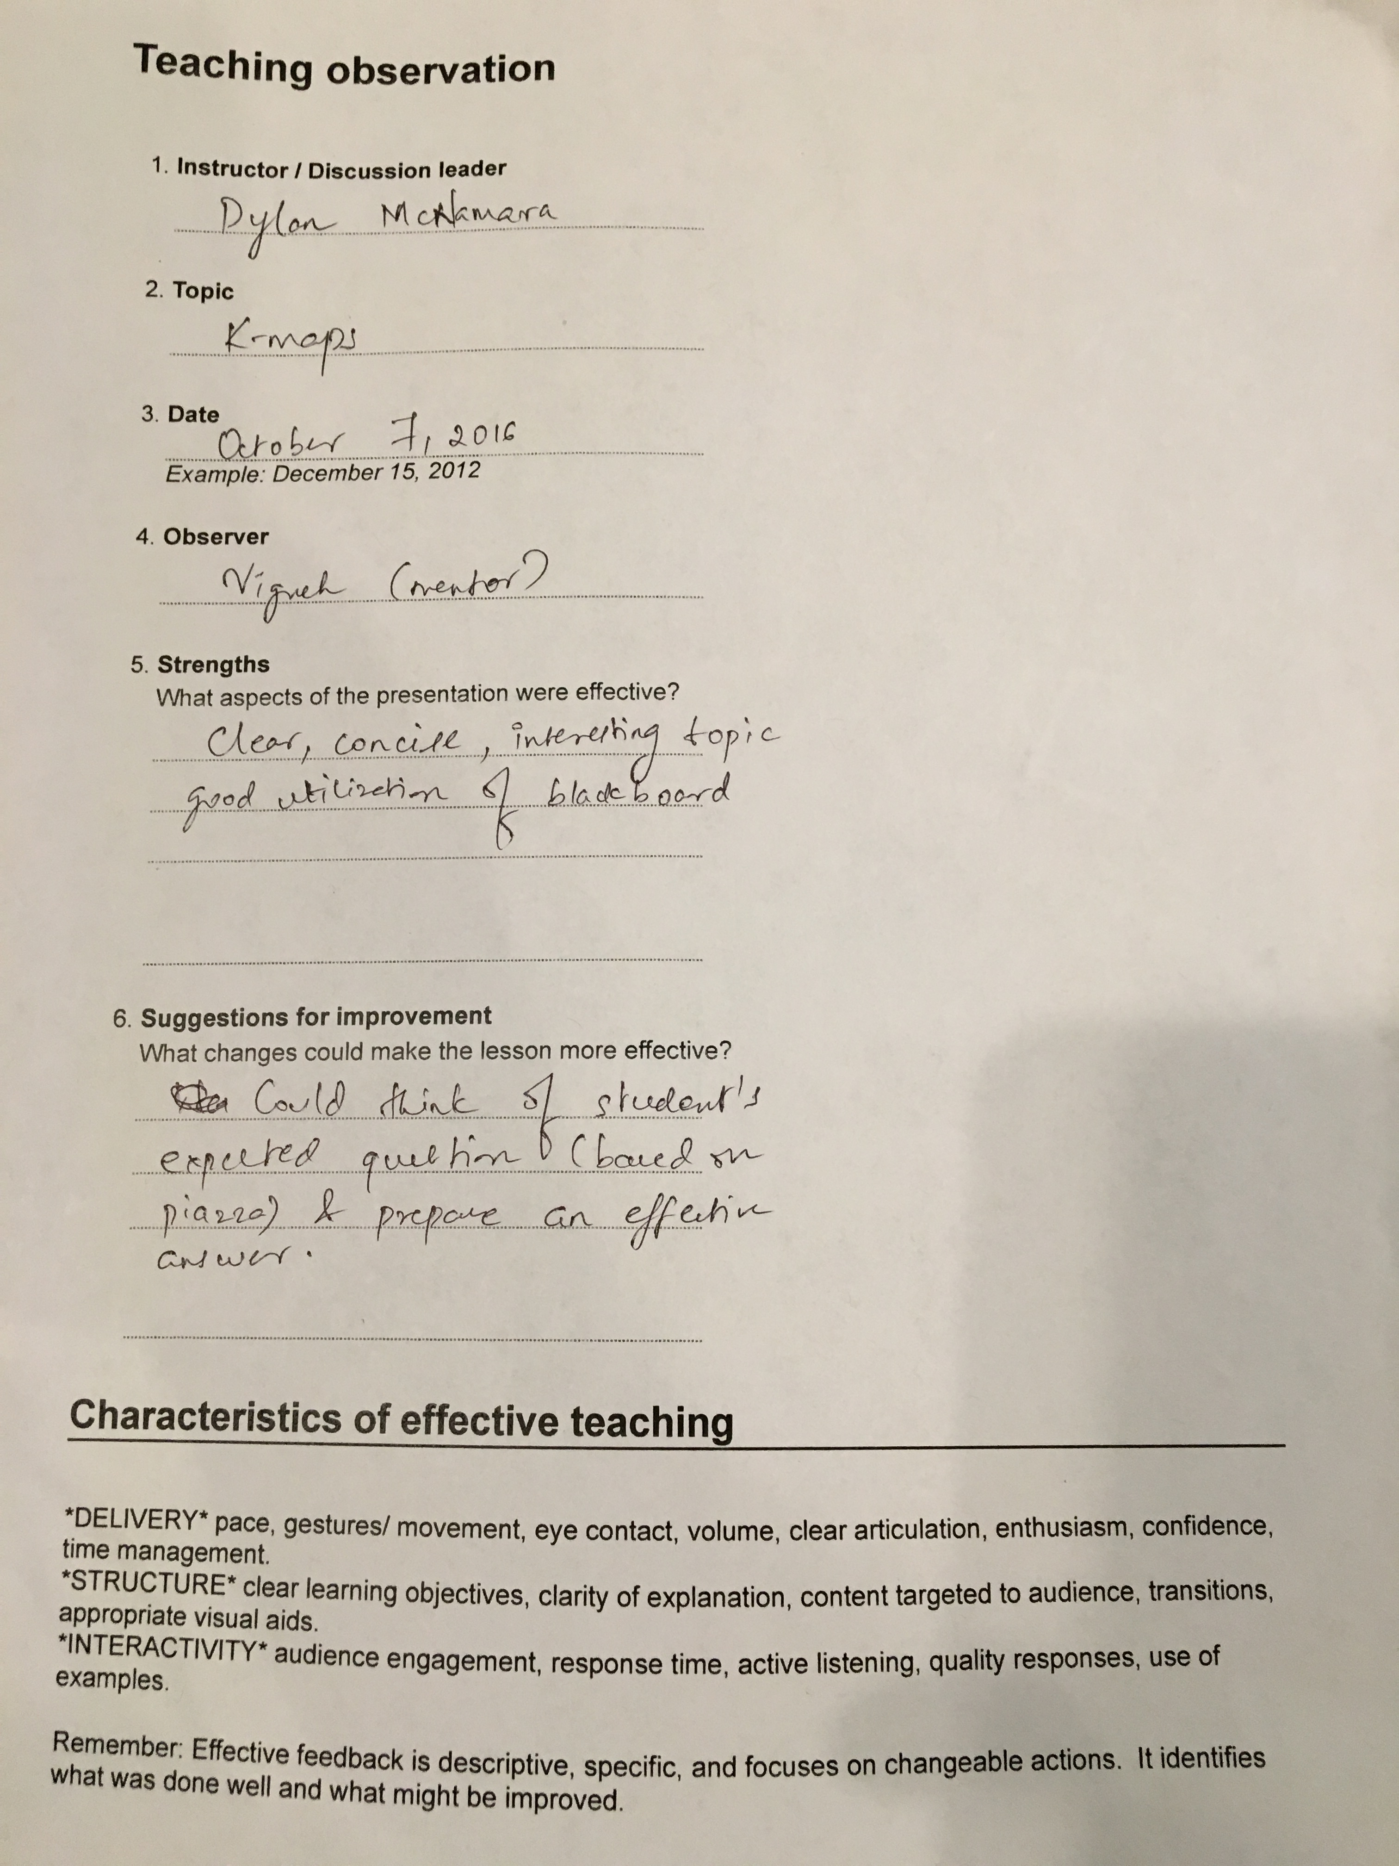

1. Week XX: observed by ____________.

**<<Include PDF / screenshot / summary of each completed Teaching Feedback Form; for practicum sessions, you should have at least 4 feedback forms>>**

*May include more than 2!*

Observing Micro-teaching / Discussion section

1. Week 3: observed **Harveen**.

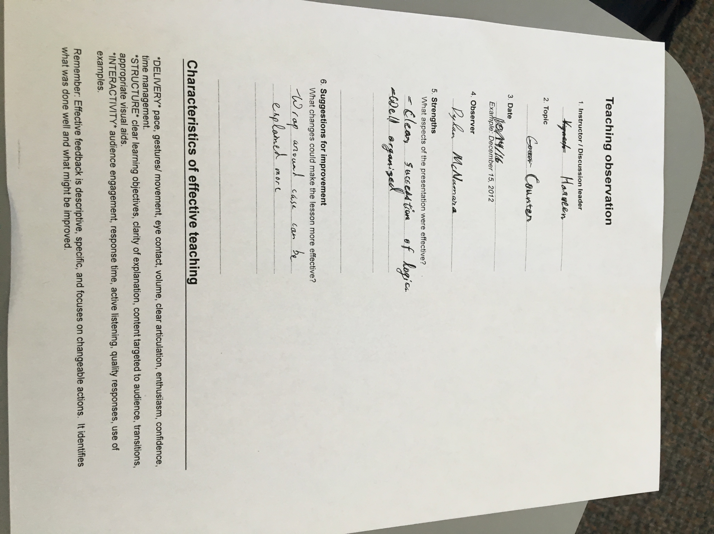

1. Week XX: observed ____________.

**<<Include PDF / screenshot / summary of completed Teaching Feedback Form>>**

*May include more than 2!*

Summary of teaching observations